**Research-centric Simulator for Swarm Robotic System**

**Activity Log**

Jeremy Lim Shih Wen

19064732

BSc (Hons) in Computer Science

Department of Computing and Information Systems

Sunway University Kuala Lumpur

Supervisor: Dr Richard Wong Teck Ken

December 2, 2022

Table of Contents

1 Timeline and Activities 3

1.1 Gantt Chart 3

1.1.1 Description of Tasks in Gantt Chart 4

2 Bibliography and Annotation 8

3 Supervision Meeting Record 13

3.1 Week 2 13

3.2 Week 4 15

3.3 Week 6 17

3.4 Week 8 20

3.5 Week 10 22

3.6 Week 13 24

# Timeline and Activities

## Gantt Chart

A Gantt chart which consists of a list of tasks and the schedule to complete these tasks is designed as shown in Figure 1. The aim of the Gantt chart is to assist in the time management of the project and ensure the success of the project.

Figure 1 Gantt chart for capstone project.

### Description of Tasks in Gantt Chart

#### Capstone Project 1

1. Briefing on capstone project 1 (Week 1)

The first week consists of a briefing on the capstone project 1 which is provided by the course coordinator. One week allocated in this task is fixed because it depends on the course coordinator.

1. Decision on topic and supervisor (Week 2)

On the second week, the final year student must decide on a topic and a supervisor for the capstone project. One week allocated in this task is fixed because it depends on the course coordinator.

1. Preparation and finalization of Gantt chart (Week 3 – Week 4)

On the third and fourth week, the Gantt chart must be completed for planning purposes. Two weeks are allocated in this task because it is done simultaneously with task 4.

1. Preparation and finalization of introduction (Week 3 – Week 5)

On the third to fifth week, the introduction section of the report must be completed. Three weeks are allocated in this task because it is done simultaneously with task 3 and requires lots of research to a new topic.

1. Preparation and finalization of literature review (Week 6 – Week 9)

On the sixth to ninth week, the literature review section of the report must be completed. Four weeks are allocated in this task because it requires a lot of research to the new topic and a lot of time is required to gather, compile, and paraphrase the content.

1. Preparation and finalization of technical plan (Week 10 – Week 13)

On the tenth to thirteenth week, the technical plan section of the report must be completed. Four weeks are allocated in this task because it requires the application and deep understanding of content in literature review.

1. Review and finalization of planning document (Week 14)

On the last week, the planning document which consists of all the previous sections, are proofread, and reviewed. One week is allocated in this task because it only summarises up the planning document.

1. Completion of timeline, bibliography, meeting records (Week 2, Week 4, Week 6, Week 8, Week 10, Week 13)

The timeline and activities, bibliography and annotations, and meeting records are done throughout 14 weeks when meeting with the supervisor are held. Multiple weeks are allocated here because the meeting records need to be done bi-weekly.

1. Submission of planning document and activity log (Week 14)

The complete planning document and activity log are submitted for evaluation.

#### Capstone Project 2

1. Develop the basic graphical user interface of simulator (Week 1)

In week 1, the basic graphical user interface of the simulator is developed using *PyQt5* library. One week is allocated in this task because the development of the GUI can be based off the drafted wireframe.

1. Develop the simulator logic of simulator (Week 2 – Week 3)

In week 2 to 3, the simulator logic is implemented such as its base functionalities. Two weeks are allocated because the content of the simulator logic may take time to learn and apply.

1. Develop the swarm logic of simulator (Week 4 – Week 5)

In week 4 to 5, the swarm logic is developed such as the swarm models and algorithms. Two weeks are allocated because the content of the swarm logic may take time to learn and apply.

1. Integrate both swarm and simulator logic into the simulator (Week 6 – Week 8)

In week 6 to 8, both the swarm and simulator logic are integrated to develop a complete simulator. Three weeks are allocated because the integration of both parts can cause many bugs.

1. Test and debug the simulator functionalities according to test cases (Week 9)

In week 9, the complete simulator is tested according to the planned test cases and debugged where necessary. One week is allocated because the functionalities of the simulator are not too complex.

1. Prepare and finalize results and discussion (Week 10)

In week 10, the results and discussion sections of the report are written. One week is allocated because results and discussion can be written off the software testing section.

1. Proofread and revise the CP1 report and make changes (Week 10)

In week 10, the previous capstone project 1 report is revised and made changes where necessary. One week is allocated here together with task 6 because the report may require some changes.

1. Prepare and finalize conclusion (Week 11)

In week 11, the conclusion section of the report is prepared and finalized. One week is allocated here because conclusion will only require summarising the whole report.

1. Proofread and revise the CP2 report and make changes (Week 11)

In week 11, the complete capstone project 2 report is proofread and revised, and changes are made where necessary. One week allocated here together with task 8 because proofreading will not take too much time.

1. Submission of Final Report and Project Files (Week 12)

In week 12, the final report and project files of the capstone project are submitted for evaluation.

1. Prepare presentation slides (Week 12)

In week 12, the presentation slides are prepared for the upcoming presentation.

1. Presentation and Demonstration of Capstone Project (Week 12 – Week 14)

From week 12 to 14, a presentation slot is booked, and the capstone project is presented to the respective examiners.

# Bibliography and Annotation

J. Song, A. Song, and F. Zhang, “RoboMaze: SWARM robotics and coordinated navigation in Smart City,” *2021 IEEE 23rd Int Conf on High Performance Computing & Communications; 7th Int Conf on Data Science & Systems; 19th Int Conf on Smart City; 7th Int Conf on Dependability in Sensor, Cloud & Big Data Systems & Application (HPCC/DSS/SmartCity/DependSys)*, 2021.

The authors, researchers of John Creeks High School and Georgia Institute of Technology, proposed a simulator for swarm robotics, *RoboMaze*. The aim to the simulator is to facilitate testing of algorithms and improve the research on smart cities. The architectural and software designs of the simulator are covered in detail in this paper. The coordinated depth-first search algorithm was tested and compared with the classical depth-first search and the differences were evaluated as a case study.

Khaldi, B., Cherif, F. An overview of swarm robotics: Swarm intelligence applied to multi-robotics. Int. J. Comput. Appl. 2015, 126, 31–37.

The authors, researchers of University of Biskra, evaluated the concepts of swarm robotics including swarm intelligence, multi-robot systems, swarm robotics, and reviewed their potential applications. The authors are evaluated the existing projects and simulation software related to swarm robotics and made a comparison between each of them. The authors found that at this moment, swarm robotics is still far from practical application, thus, they provided an overview to the topic.

A. Liekna and J. Grundspenkis, “Towards practical application of swarm robotics: Overview of swarm tasks,” *Engineering for rural development*, May 2014.

The authors, researchers of Riga Technical University, summarized the tasks for swarm robotics and evaluated the practicality of each task for real world applications. The authors discussed each task of swarm behaviours in detail and stated how each task can be applied practically. The authors also mentioned that to benefit from swarm robotic systems, a combination of more than one tasks are required to produce more complex behaviours and increase practicality of swarm robotic systems.

J. C. S de Sá, “RViz Based Simulation For Motion Control Of Swarm Robotics,” 2022.

The author, researcher of University of Porto, evaluated the concepts of ground and aerial robotic vehicles, and four well-known simulators, i.e., Player/Stage, Gazebo, ARGoS, and V-REP. The author aims to create a swarm robotic simulator that is more computational efficient than the discussed simulators. The author then proposed their own simulator which is capable of simulating aerial swarm using swarm algorithms. The author evaluated their simulator in comparison to the mentioned simulators and proved that the author’s simulator was more computationally efficient.

P. S. Andrews, S. Stepney, and J. Timmis, “Simulation as a scientific instrument,” *Proceedings of the 2012 workshop on complex systems modelling and simulation*, 2012.

The authors, researchers of University of York, evaluated the viability of using computer simulations as a scientific instrument. Due to sceptical scientists doubting the benefits of computer simulations, the authors discussed the concepts of computer simulation and made comparison with other scientific instruments to improve the acceptance of computer simulations as a scientific instrument in the research field. The authors noted that simulators are more trustworthy as open source which allows flexibility to determine how the simulations are engineered and improve their knowledge domain.

N. Nedjah and L. S. Junior, “Review of methodologies and tasks in swarm robotics towards standardization,” *Swarm and Evolutionary Computation*, vol. 50, p. 100565, 2019.

The authors, researchers of University of Rio de Janeiro, reviewed the different directions of swarm robotics research in-depth and provided an overview on the research of simulations compared to physical robots. The authors also discussed the swarm behaviours of the swarm robotics systems and their techniques of implementation by integrating soft computing. The authors emphasised that swarms of underwater robots and Unmanned Aerial Vehicles are increasingly popular and require a proper survey of these technologies.

A. R. Cheraghi, S.Shahzad, and K. Graffi, “Past, present, and future of swarm robotics,” In *Proceedings of SAI Intelligent Systems Conference* (pp. 190-233). Springer, Cham, 2021.

The authors, researchers of Heinrich Heine University and Honda Research Institute, discussed the concepts of swarm robotics and its history. The benefits, limitations, categories, features, and real-life applications were also evaluated in detail. The authors also made comparison between existing simulators and platforms. The authors concluded that the field of swarm robotics is far from perfect at replicating the natural swarm behaviours.

J. C. Barca and Y. A. Sekercioglu, “Swarm robotics reviewed,” Robotica, vol. 31, no. 3, pp. 345–359, 2013.

The authors, researchers of Monash University, reviewed the process of improving the practicality of swarm robotic system for real world applications. The authors evaluated the history, pros and cons of swarm robotic systems, and the application of swarm robotics. The authors also reviewed multiple types of physical robots that can apply swarm robotics. The authors identified eight issues that need to be addressed in swarm robotics. These issues include the need for a hybrid distributed scheme, a self-organizing system, scalable and robust systems, energy efficiency systems, facilitation of mapping and localization mechanisms, systems that can implement path planning and obstacle avoidance without a leader, systems that can transport items efficiently, and systems that do not malfunction prematurely from loss of energy source.

G. Beni, “The concept of cellular robotic system,” in Proceedings IEEE International Symposium on Intelligent Control 1988, Aug 1988, pp. 57–62.

The author, researcher of University of California Santa Barbara, discussed the theories to engineer a new type of robotic system, cellular robotics, which comprise of autonomous robots that coordinate to complete tasks. The authors establish the fundamental properties of the system and evaluated the differences of the system with neural networks and cellular automation. The authors demonstrated the practical significance of their work in different fields such as distributed computing, molecular computing, and two-dimensional languages.

T. Fukuda and S. Nakagawa, “Approach to the dynamically reconfigurable robotic system,” Journal of Intelligent and Robotic Systems, vol. 1, no. 1, pp. 55–72, 1988.

The authors, researchers of The Science University of Tokyo, proposed a new system named dynamically reconfigurable robotic system. The authors discussed the concept of the system, the specifications, and optimal configurations of the system together with the results of their testing and simulations.

G. Beni, and J. Wang, “Swarm Intelligence in Cellular Robotic Systems. Robots and biological systems: towards new bionics,” pp. 703--712. Berlin, Springer, 1993.

The authors, researchers of University of California, defined the concepts of robot intelligence and robot system intelligence and determined their unpredictable behaviours which are analysed in detailed in this paper. The authors expect that the theory of dynamic and computational systems will emerge from the foundation of robotic science.

G. Beni, “From swarm intelligence to swarm robotics,” in Swarm Robotics Workshop: State-of-the-Art Survey, E. Şahin and W. Spears, Eds., no. 3342, pp. 1–9, Springer, Berlin, Germany, 2005.

The author, researcher of University of California, discussed the definition of common terms in swarm robotics such as swarm, swam robotics, swarm intelligence, swarm engineering, and swarm optimization. The aim of this paper is to clarify any subjectivity in these concepts and provided clearer robotics concepts.

E. Osaba, J. Del Ser, A. Iglesias, and X.-S. Yang, “Soft computing for swarm robotics: New trends and applications,” *Journal of Computational Science*, vol. 39, p. 101049, 2020.

The authors, researchers of University of the Basque Country, University of Cantabria, Toho University, and Middlesex University London, discussed on the overview of the field of swarm robotics and mentioned the capabilities of distributed intelligence. The authors encourage other researchers to put effort into the integration of swarm intelligence methods in robotic swarms for future applications due to their vast benefits and potential.

D. P. Cruz, R. D. Maia, and L. N. De Castro, “A critical discussion into the core of swarm intelligence algorithms,” Evolutionary Intelligence, 12(2), 189—200, 2019.

The authors, researchers of University of Mackenzie University and State University of Montes Claros, discussed on the swarm intelligence algorithms including the common features of famous swarm-based algorithms and how each algorithm is implemented. The aim of this paper is to provide the community the essential features of swarm algorithms which include the ant colony optimization, artificial bee colony, ant clustering algorithm, spider swarm optimization, and firefly algorithm.

X.-S. Yang, S. Deb, Y.X. Zhao, S. Fong, X.S. He, Swarm intelligence: past, present and future, Soft Computing, 10.1007/s00500-017-2810-5, 2017.

The authors, researchers of Middlesex University, Victoria University, Harbin Engineering University, University of Macau, Xi’an Polytechnic University, reviewed the concepts of swarm intelligence and its relevant algorithms, and its application in self-organization systems. The authors then focused on few of the swarm intelligence algorithms and proposed a more theoretical approach using Markov chain theory, fixed-point theory, and dynamic systems. The authors concluded the paper by describing the challenges and recommendations to overcome the challenges.

R. Eberhart and J. Kennedy, “A new optimizer using particle swarm theory,” in Micro Machine and Human Science, 1995. MHS’95., Proceedings of the Sixth International Symposium on. IEEE, 1995, pp. 39–43.

The authors, researchers of Purdue School of Engineering and Technology and Bureau of Labor Statistics, discussed the concept of particle swarm optimization, determined methods to train a multilayer perceptron, and generated the two neural network models for the algorithm and made comparison between the two models. The authors found that the GBEST algorithm performs better with fewer median number of iterations to convergence whereas the LBEST algorithm with two neighbours is more resistant to local minimum.

# Supervision Meeting Record

## Week 2

**SCHOOL OF ENGINEERING AND TECHNOLOGY**

**DEPARTMENT OF COMPUTING AND INFORMATION SYSTEMS**

**SUPERVISION MEETING RECORD**

Date: 1 September 2022

Time: 10:00 a.m. – 11:00 a.m.

Student: Jeremy Lim Shih Wen

Supervisor: Dr Richard Wong Teck Ken

Updates from the previous meeting:

* N/A

Items discussed this meeting:

* Briefing on the content of capstone project 1
* Plan for upcoming meetings with supervisor

Work for the coming meeting (15 September 2022):

* Draft of introduction section of topic
* Planning/timeline of project

Supervisor’s Signature Student’s Signature



………………………………. ……………………………….



Relevant notes:

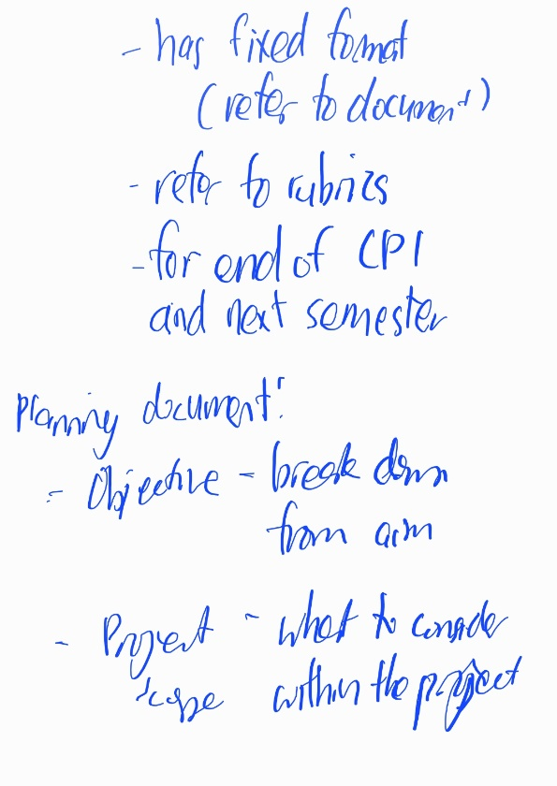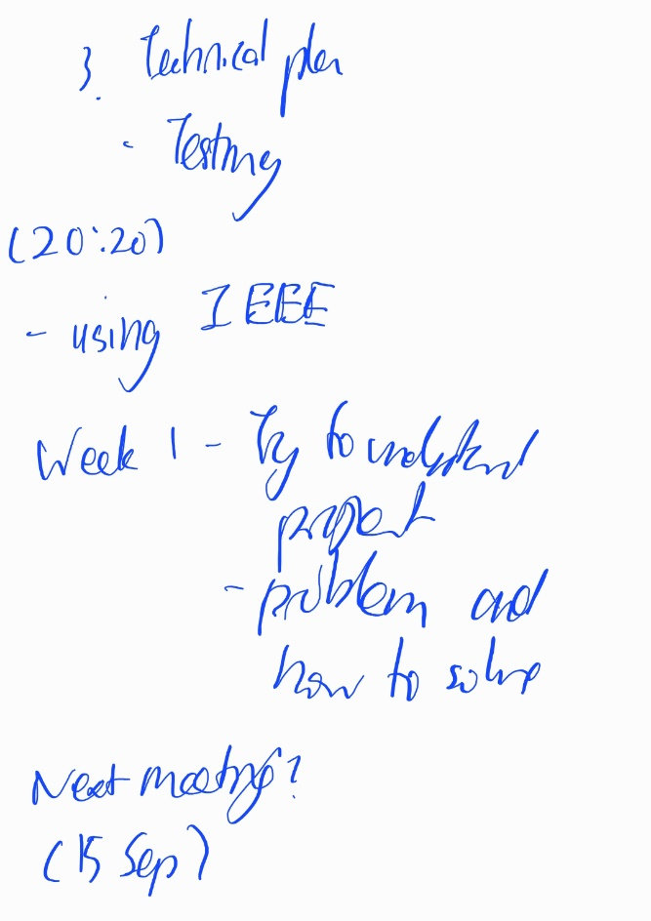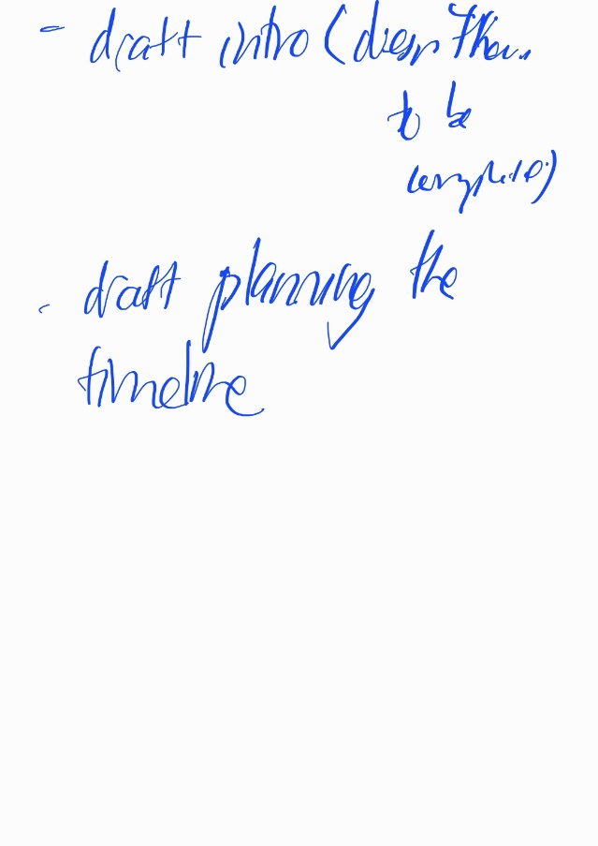

## Week 4

**SCHOOL OF ENGINEERING AND TECHNOLOGY**

**DEPARTMENT OF COMPUTING AND INFORMATION SYSTEMS**

**SUPERVISION MEETING RECORD**

Date: 15 September 2022

Time: 2:00 p.m. – 3:00 p.m.

Student: Jeremy Lim Shih Wen

Supervisor: Dr Richard Wong Teck Ken

Updates from the previous meeting:

* Prepared introduction draft and work plan

Items discussed this meeting:

* Review of introduction
* Clarification on content issues

Work for the coming meeting:

* Research on literature review and technical plan
* Plan on technical plan

Supervisor’s Signature Student’s Signature



………………………………. ……………………………….

Relevant notes:

## Week 6

**SCHOOL OF ENGINEERING AND TECHNOLOGY**

**DEPARTMENT OF COMPUTING AND INFORMATION SYSTEMS**

**SUPERVISION MEETING RECORD**

Date: 29 September 2022

Time: 2:00 p.m. – 3:00 p.m.

Student: Jeremy Lim Shih Wen

Supervisor: Dr Richard Wong Teck Ken

Updates from the previous meeting:

* Research on literature review and technical plan
* Plan on technical plan

Items discussed this meeting:

* Structure of literature review
* Relevant topics in literature review
* Planning of technical plan

Work for the coming meeting:

* Review of literature review topics
* Structure of technical plan
* Draft of activity log

Supervisor’s Signature Student’s Signature



………………………………. ……………………………….

Relevant notes:

## Week 8

**SCHOOL OF ENGINEERING AND TECHNOLOGY**

**DEPARTMENT OF COMPUTING AND INFORMATION SYSTEMS**

**SUPERVISION MEETING RECORD**

Date: 20 October 2022

Time: 2:00 p.m. – 3:00 p.m.

Student: Jeremy Lim Shih Wen

Supervisor: Dr Richard Wong Teck Ken

Updates from the previous meeting:

* Review of literature review topics
* Structure of technical plan
* Draft of activity log

Items discussed this meeting:

* Review of literature review content
* Structure and draft of technical plan

Work for the coming meeting:

* Completion of literature review
* Content of technical plan

Supervisor’s Signature Student’s Signature



………………………………. ……………………………….

Relevant notes:

## Week 10

**SCHOOL OF ENGINEERING AND TECHNOLOGY**

**DEPARTMENT OF COMPUTING AND INFORMATION SYSTEMS**

**SUPERVISION MEETING RECORD**

Date: 3 November 2022

Time: 2:00 p.m. – 3:00 p.m.

Student: Jeremy Lim Shih Wen

Supervisor: Dr Richard Wong Teck Ken

Updates from the previous meeting:

* Completion of literature review
* Content of technical plan

Items discussed this meeting:

* Part of literature review

Work for the coming meeting:

* Completion of literature review
* Completion of technical plan

Supervisor’s Signature Student’s Signature



………………………………. ……………………………….

Relevant notes:

Useful literatures for evaluating simulators for swarm robotics systems:

1. Feature and performance comparison of the V-REP, Gazebo and ARGoS robot simulators
2. Swarmflawfinder
3. Exploration in Extreme Environments with Swarm Robotic System
4. Swarm robotics
5. Swarm Robotics: A Perspective on the Latest Reviewed Concepts and Applications
6. Robot Swarm Navigation: Methods, Analysis, and Applications
7. An Introduction to Swarm Robotics
8. An Overview of Swarm Robotics: Swarm Intelligence Applied to Multi-robotics
9. Past, Present, and Future of Swarm Robotics **(extremely useful)**
10. Probabilistic Aggregation Strategies in Swarm Robotic Systems
11. Swarm Robotics: Simulators, Platforms and Applications Review **(extremely useful)**
12. Kilombo: a Kilobot simulator to enable effective research in swarm robotics
13. Swarm-Sim: A 2D & 3D Simulation Core for Swarm Agents
14. RoboMaze
15. Simulation software and virtual environments for acceleration of agricultural robotics: Features highlights and performance comparison
16. SwarmLab: a MATLAB Drone Swarm Simulator (**extremely useful)**
17. RViz based simulation for motion control of swarm robotics (**extremely useful)**

## Week 13

**SCHOOL OF ENGINEERING AND TECHNOLOGY**

**DEPARTMENT OF COMPUTING AND INFORMATION SYSTEMS**

**SUPERVISION MEETING RECORD**

Date: 24 November 2022

Time: 2:00 p.m. – 3:00 p.m.

Student: Jeremy Lim Shih Wen

Supervisor: Dr Richard Wong Teck Ken

Updates from the previous meeting:

* Completion of literature review
* Completion of technical plan

Items discussed this meeting:

* Technical plan

Work for the coming meeting:

* N/A

Supervisor’s Signature Student’s Signature



………………………………. ……………………………….

Relevant notes:

